**Experiment no:3 Date:09-03-2023**

**Aim:** Familiarization with Linux command.

**CO2:** Perform system administration tasks.

**Procedure:**

1. pwd: to print the working directory.

**.** print the path of the working directory.

$pwd

Output:



1. ls: Used to list the files and contents

$ls

Output:



1. ls -R: This will list all the subdirectories

$ls -R

Output:

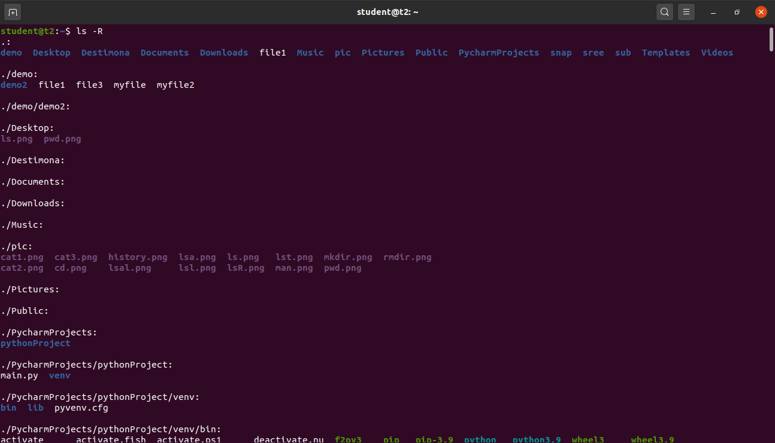

1. ls -l: long listing,

$ls -l

Output:

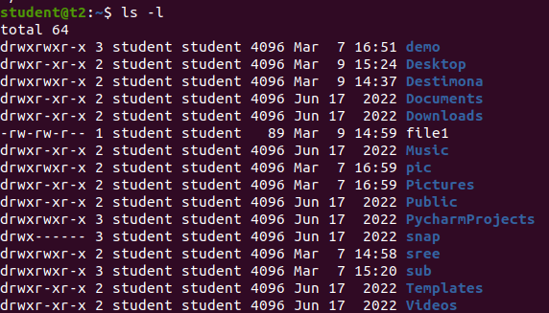

1. ls -a: To view the hidden files.

$ls -a

Output:



1. ls -al: list the files and directories with detailed information including hidden files.

$ls -al

Output:

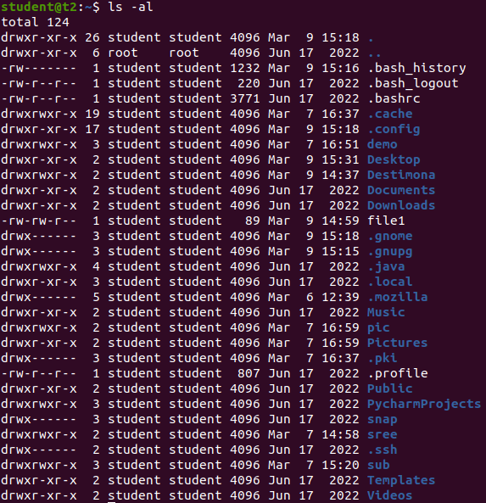

1. ls -t: list the files in sorted in the order of last modified.

$ ls -t

Output:



1. ls -r: reverse the actual sorting order.

$ls -r

Output:



1. mkdir: to make the directory

$mkdir [filename]

Output:



1. cd: to navigate through the directory.

$cd [filename]

Output:



1. cd -- / cd ..: to go to the previous directory.

$cd ..

Output:



1. history: To view the history and the commands which you have been executed for certain period of time.

$history

Output: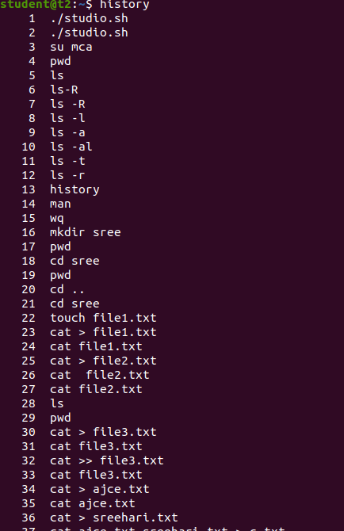

1. man: we can learn and understand about the shell using man command.

$man ls

Output: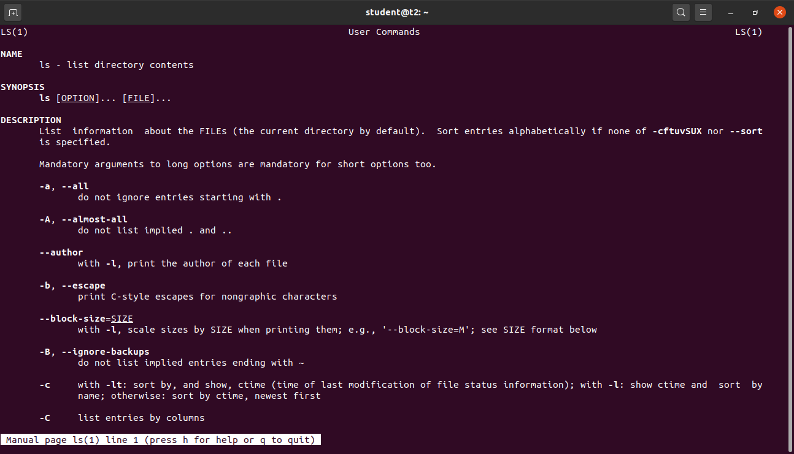

1. cat: to create file.
2. $cat > [filename]

Output:

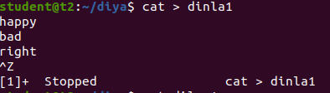

1. cat [filename]: to display the file contents.

$ cat dinla1

Output:

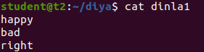

1. cat >> [filename]: to append the file.

$cat >> dinla1

Output:

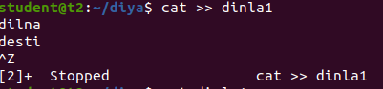

1. cat -n [filename]: to display the line number.

$cat -n dinla1

Output:

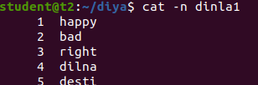

1. cat -b [filename]: to remove numbering from empty line.

$cat -b dinla1

Output:

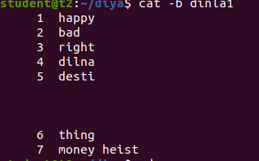

**Experiment no:4 Date:10-03-2023**

**Aim:** Familiarization with Linux command.

**CO2:** Perform system administration tasks.

**Procedure:**

1. cut -c 1 [filename]: For cutting out the section from each line and write the result for standard output.

$cut -c 1,3,5 newfile

Output:

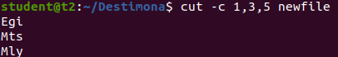

i.cut -b 2[filename]:Cut by position.

$cut -b 1,2 newfile

Output:

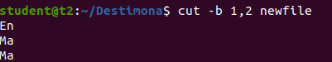

ii.cut -d [filename] -f1 [filename]:To cut by delimiter.

$cut -d - -f1 newfile

$cut -d - -f2 newfile

Output:

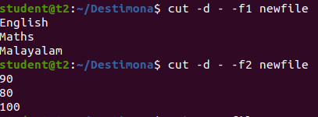

iii.cut -compliment -c 1 [filename]:To cut by delimiter.

$ cut - -complement -c 1 newfile

Output: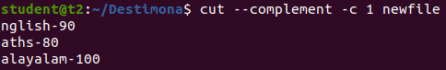

2. paste [filename] [filename]:To paste the content of one file to another.

$paste myfile2 myfile1

Output:

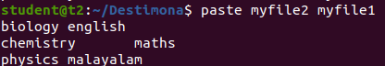

i.paste -d ‘%’ [filename] [filename] >[filename]:To paste filr to another file by delimer.

$ paste -d ‘%’ mark1 mark2 > mark3

Output:

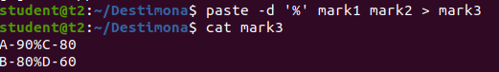

3.cp [filename] [filename]:Use to copy a file or dictionary.

$cp test test1

Output :

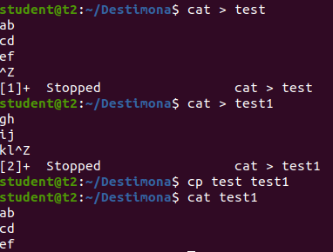

i. cp -r [filename] [filename] :to copy file.

$cp -r Destimona desti

Output:

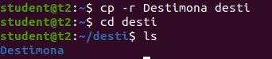

**Experiment no:5 Date:16-03-2023**

**Aim:** Familiarization with Linux command.

**CO2:** Perform system administration tasks.

**Procedure:**

1.Read : To read the content of a line

$read

Output:

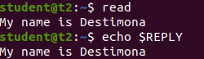

i.read[var1] [var2][ var3]... :To assign content to variable

$read var1 var2 var3

Output:

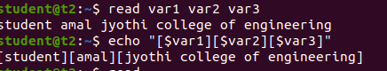

ii.$read : For displaying multiple lines

Output:

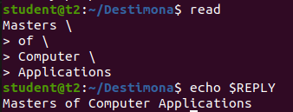

iii.read -p :To prompt message from user

$read -p :

Output:

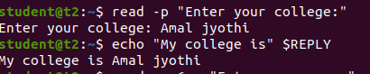

iv.read -n 6 -p : To specify the limit of entry

$read -n 6 -p “Enter your name:”

v.read -s -p: To prompt the message and for secure

$read -s -p”Enter your password:”

Output:

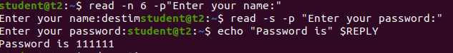

2.wc(count count): It is used to display the number of lines,number of words,number of bytes

$wc

Output:



i.wc -l[filename] : To display the number of lines

$wc -l mytest

Output:



ii.wc -L[filename] : It is used to find the length of longest line

$ wc-L mytest

Output:



iii.wc -c[filename]

iv.wc -m[filename] : Both are used to display the number of characters

$wc -c mytest

$wc -m mytest

Output:





3. more : The more command read files and display the text one screen at a time

$more [filename]

Output:

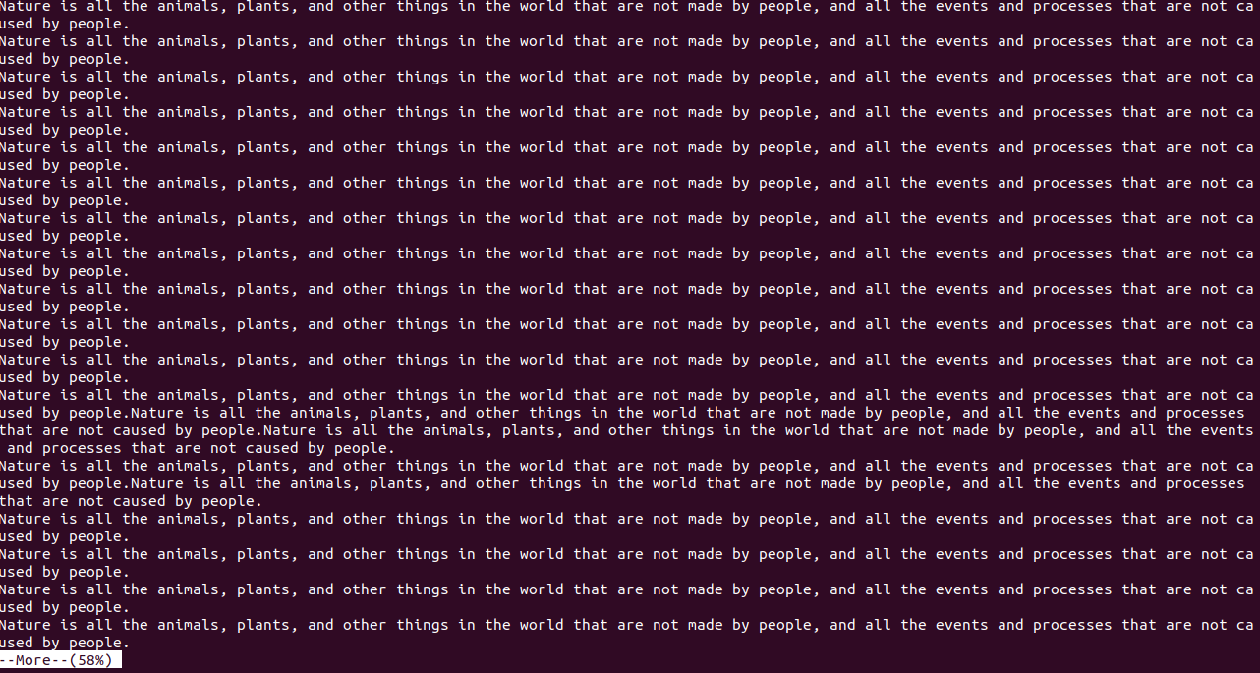

i. more -5[filename] : To display contents after 5 lines

$more -5 test

Output:

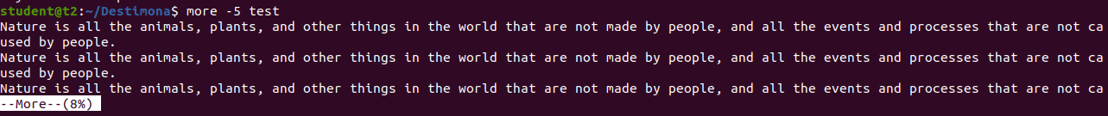

ii. more +/[content][filename] : To search the contents of a file

$more +/animal test

Output:

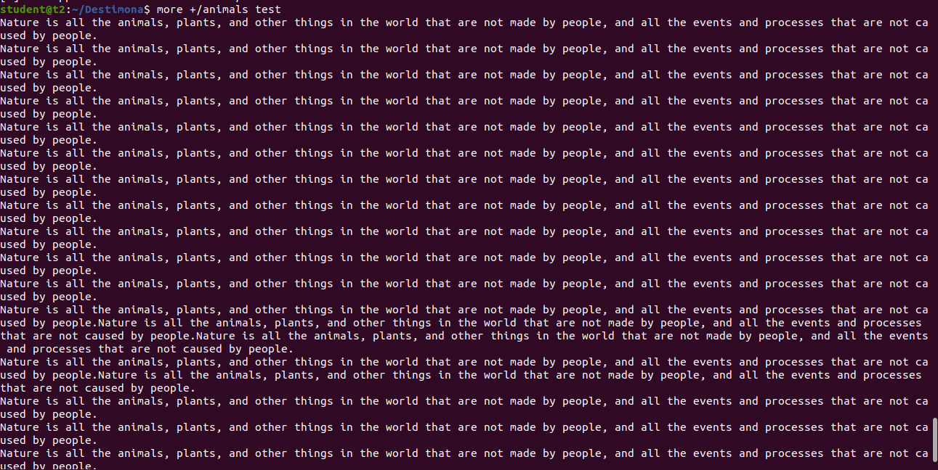

iii.more -d[filename] : To display user message at right corner

$more -d test

Output:

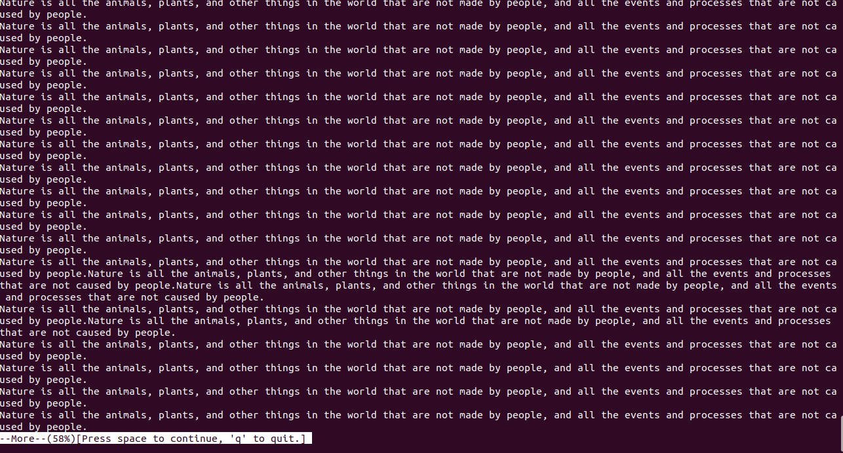

4. less : It shows a files contents one screen at a time

i. ctrl+f : Forward one window

ii. ctrl+d : Forward half window

iii. ctrl+b : Backward one window

iv. ctrl+u : Backward half window

v. ctrl+j : Forward one line

vi. ctrl+k : Backward one line

**Experiment no:6 Date:17-03-2023**

**Aim:** Familiarization with Linux command.

**CO2:** Perform system administration tasks.

**Procedure:**

1. grep : Grep filters a content of a file,which make our search easy

grep [content][filename]

$grep 95 mark1

Output:



i.grep -i[content][filename]

$grep -i ENGLISH mark1

Output:



ii.grep -A1[content][filename] : To display one line after the search content

$grep -A1 science mark1

Output:



iii.grep -B1[content][filename] : To display one line before the search content

$grep -B1 science mark1

Output:

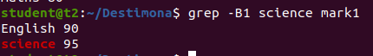

iv.grep -C1[content][filename] : To display one line before and after the search content

$grep - C1 science mark1

Output:

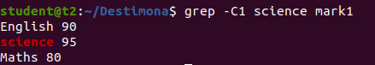

v. grep -V[content][filename] : To display the content except the searched content

$grep -V Malayalam mark1

Output:

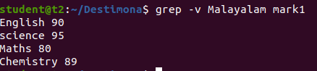

vi. cat[filename] | grep [content]

$ cat mark1 | grep 8

Output:

1. head [filename] : It is used to print the first 10 lines of the specified file

$head lines

Output:

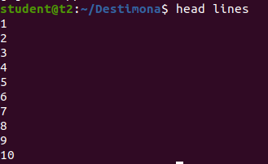

i. head -5[filename] : To display the first five lines in the file

$ head -5 lines

Output:

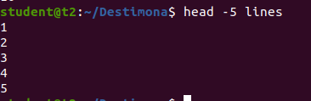

1. tail [filename] : It is used to print the below 10 lines of the specified file

$tail lines

Output:

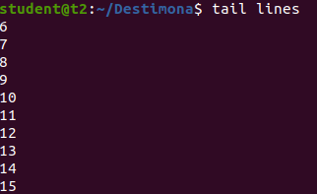

i. tail -5[filename] : To display the last five lines in the file

$tail -5 lines

Output:

